The 19th RoboCup World Competition and Symposium

PARTICIPATION GUIDELINES

LOC of RoboCup 2015
July 2015

- Venue Information
- Major Teams: Anhui International Conference &Exhibition Center (main venue)
Address: Fanhua Road, Hefei Economic and Technological Development Area
Opening Hours: 8:00 am -11:00 pm, the air conditioner will close at 10:00 pm
- Junior Teams: Hefei Olympic Sports Center
Address: Southwest corner of the intersection of Xiyou Road and Qianshan Road, Hefei New Municipal and Culture District Development
Opening Hours: 8:00 am -11:00 pm, the air conditioner will close at 10:00 pm

- Schedule
Date | Topic | Participant | Address
17th-18th July | On-site Registration  9:00 am  - 5:00 pm | All participants to the event except those to RCJ | Anhui International Conference & Exhibition Center (Gate 1)
17th-18th July | On-site Registration  9:00 am  - 5:00 pm | All participants to RCJ | Hanlin Olympic Hotel (Lobby)
17th-18th July | Team Setup  8:00 am- 10:00 pm | Major Team Members and Staff | Anhui International Conference &Exhibition Center
17th-18th July | Team Setup  8:00 am- 10:00 pm | Junior Team Members and Staff | Hefei Olympic Sports Center (Basketball hall)
19th July | Opening Ceremony 9:00 am | Participants and Guests | Anhui International Conference & Exhibition Center
19th July | Competitions 9:50 am-10:00 pm | Major Teams | Anhui International Conference & Exhibition Center
19th July | Competitions 9:00 am-10:00 pm | Junior Teams | Hefei Olympic Sports Center (Basketball hall)
20th July | Competitions 8:00 am-10:00 pm | Major Teams | Anhui International Conference & Exhibition Center
20th July | Competitions 8:00 am-10:00 pm | Junior Teams | Hefei Olympic Sports Center (Basketball hall)
20th July | Workshop on Benchmarking Service Robots  9:00 am-5pm | Participants, Invited speakers and Guests | Meeting Room #1, 3rd floor, Anhui International Conference & Exhibition Center
21st July | RoboCup 2015 Ecosystem Summit 9:00 am | Participants, Invited speakers and Attendees | Multi-function Hall, 2nd floor, Anhui International Conference &Exhibition Center (Multifunctional Hall)
21st July | Semi-finals 8:00 am-10:00 pm | Major Teams | Anhui International Conference & Exhibition Center
21st July | Semi-finals 8:00 am-10:00 pm | Junior Teams | Hefei Olympic Sports Center (Basketball hall)
22nd July | Finals  9:00am - 3:00 pm | Major Teams | Anhui International Conference & Exhibition Center
22nd July | Finals  9:00am - 3:00 pm | Junior Teams | Hefei Olympic Sports Center (Basketball hall)
22nd July | Award Ceremony  4:00 pm | Major Teams | Anhui International Conference & Exhibition Center
22nd July | Award Ceremony  4:00 pm | Junior Teams | Hefei Olympic Sports Center (Basketball hall)
23rd July | RoboCup Symposium | Participants, Invited speakers and Attendees | Multi-function Hall, 2nd floor, Anhui International Conference & Exhibition Center

- Picking-up, On-site Registration, and Shuttle Schedule
(1) We will provide consulting service at the exits of Beijing, Shanghai and Guangzhou international airports from 14th July to18th July.
Contacts:
Beijing: 18110913292 (Hu Weiguang)
Shanghai: 15856999261 (Wang Lirong)
Guangzhou: 18756072905 (Li Fangfang)
(2) On-site registration will be open on 17th and 18th at the two venues. And picking-up will be available on 15th and 18th. Transfer shuttles will be waiting for all participants at Hefei Xinqiao International Airport, Hefei Railway Station and Hefei South Railway Station (24-hour service).
(3) Competitions will be held during July 19th to 22nd. During the period, we will provide shuttles travelling in between the hotels and the venues from 7:00 am to 8:00 am (only at the recommended hotels).
(4) Transfer shuttles will also be available during the day at regular time between Anhui International Conference & Exhibition Center and Hefei Olympic Sports Center.
(5) During the registration and competition periods, it would be convenient if the competition teams can provide details of your leaving flights, so that the organization can arrange transfer shuttles for you at the end of the competition. Please provide necessary details in time, otherwise, no transfer shuttles may be assigned to your team.
(6) More detailed information about shuttle can be found at:
a. The official website of RoboCup 2015
b. Bulletin board at hotels
c. Notice board at the service center in the venue.

- Food &Beverage Information (Not restricted, make your own plans, you may buy it at your own cost.)
(1) Hefei Olympic Sports Center
Food Supplier: Hanlin Olympic Hotel
Opening Hours: Breakfast: 7:00 am-9:00 am
Lunch: 11:00 am-2:00 pm
Dinner: 5:00 pm-8:00 pm
Contact Us: 18326125177 (Wang Zengyin)
Address: Gymnasium of Hefei Olympic Sports Center (Second Floor Aisle C)

(2) Anhui International Conference &Exhibition Center
Food Supplier: Hui Shang Gu Li
Opening Hours: Lunch: 10:00 am-2:00 pm
Dinner: 5:00 pm-8:00 pm
Address: Gate 5 Dining Area

Food Supplier: Coffee Time
Opening Hours: 8:00 am-10:00 pm
Address: Gate 5 Dining Area

Food Supplier: Wallace
Opening Hours: Lunch: 10:00 am-2:00 pm
Dinner: 5:00 pm-8:00 pm
Contact Us: 13965099178 (Zhen Qian)
Address: The front platform of Auditorium and International Hall on the ground floor of Conference Area

(3) Free spring water, provided by our sponsors, can be found in the venue. You may acquire with your attending permit or identification card (maximum 2 bottles per person per day).
(4) There will be a Dining Service Center in the main venue.
(5) If you request for Halal food, please approach to our volunteers, further arrangement will be made.
Food Supplier: Lanzhou Hand-pulled Noodles
Opening Hours: 8:00 am-9:00 pm
Contact Us: 15256044017
Address: The intersection of Cuiwei Road and Songgu Road, opposite side of east gate Donghai Garden

(6) Two prayer rooms are located inside the main venue, please ask our volunteers for details if needed.

(7) Other Food Suppliers nearby Anhui International Conference &Exhibition Center
Food Supplier: Home Original Chicken
Opening Hours: 24H
Contact Us: 0551-63836167
Address: The intersection of Jinzhai Road and Cuiwei Road

Food Supplier: KFC
Opening Hours: 24H
Contact Us: 0551-63814568、13063497755
Address: The intersection of Jinzhai Road and Furong Road, nearby Lotus Market

(8) Other Food Suppliers nearby Hefei Olympic Sports Center
Food Supplier: U.B.C Coffee
Opening Hours: 9:00 am-00:00 pm
Contact Us: 0551-66559808, 18256968981 (Li Cuicui)
Address: The intersection of Xiyou Road and Qianshan Road, Hefei New Municipal and Culture District Development (inside Hefei Olympic Sports Center)

- Foreign Currency Exchange
a. China Everbright Bank (CEB)
Service Window: Window No. 8, Window No. 9 (VIP room)
Opening Hours: 9:00 am-5:00 pm (Mon.-Fri.)
9:30 am-4:30 pm (Sat., Sun.)
Contact Us: 18605659272 (Chen Xiao)
Address：Southwest corner of the intersection of Jinzhai Road and Fanhua Road, 283 Fanhua Road, Hefei Economic and Technological Development Area (nearby Gentlefolk Hotel)
b. Bank of China (BOC)
Service Window: Window No. 1
Opening Hours: 8:30 am-4:30 pm
Contact Us: 0551-63812445, 18655755592 (Wu Yi)
Address: Northwest corner on the ground floor of Lotus Market, the intersection of Furong Road and Jinzhai South Road, 291 Furong West Road, Hefei Economic and Technological Development Area
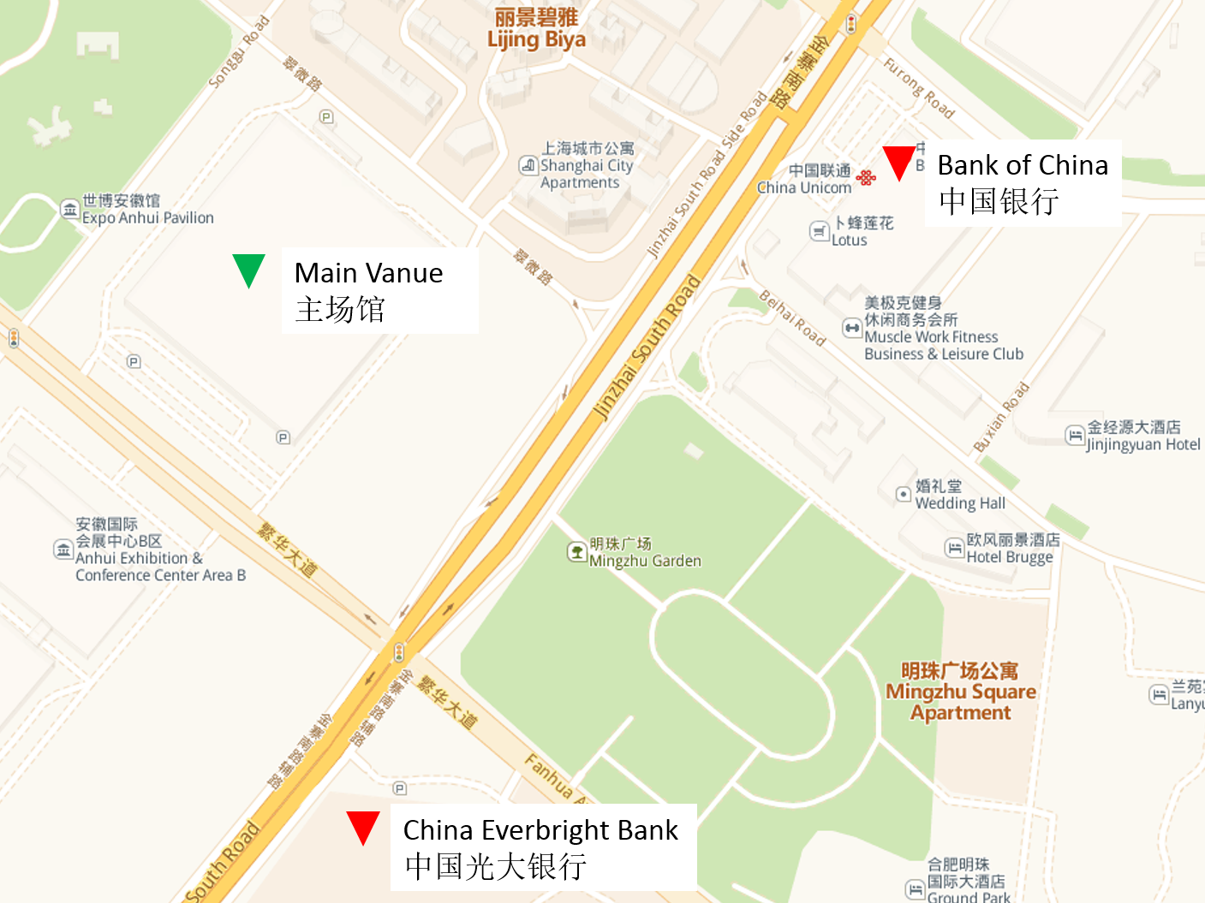

- Information Center
Consulting service will be provided during the whole competition periods in each center:
a. Anhui International Conference &Exhibition Center (main venue)
b. Hefei Olympic Sports Center

7. Chaperone Visiting Tickets
a. Visiting tickets can be obtained in the designated area.
b. Visiting tickets can only be obtained by participants’ family members.
c. Please apply for it in advance if needed.
d. Application method:
Please fill in the attached form for details and send it back as Excel format to robocuphf2015@163.com. The organization will leave the tickets in advance, please ask for the tickets with identification during registration.
Name | Team | Nation/Region | Hotel | Check-in time | Chaperone's Name
 |  |  |  |  | list all the chaperone's name here

8. As in the previous events, all participants are required to sign the Consent Form, which consists of two parts about risks and about release. Please sign and bring the hardcopy to the registration counter at the venue (Anhui International Conference and Exhibition Center for major and Hefei Olympic Sports Center for junior). You will get your badge and other materials after submitting the signed consent form.

